**Daily Scrum or Standup Meeting**

Team name: Group 2

Scrum Master: Max Edwards

Date:___________________March 2 Autopilot___________

| **Team Member** | **What did you do since the last scrum?** | **What do you plan to do before the next scrum?** | **What obstacles do you have?** |
| --- | --- | --- | --- |
| Satchell Fausett | Started to put in serializers | Work on Authorization and test it | Spring break  Images collection |
| Jared Hansen | Enhance my understanding of React principles | Design the component for vehicle display | Spring break  Midterms |
| Chase Miller | Worked on authorization setup | Write some unit tests for the vehicle endpoints | Spring break  Claire |
| Max Edwards | I reviewed a little more backend code | Integrations for login user forms | Spring break  Reptile Tracker |
|  |  |  |  |

# Burndown

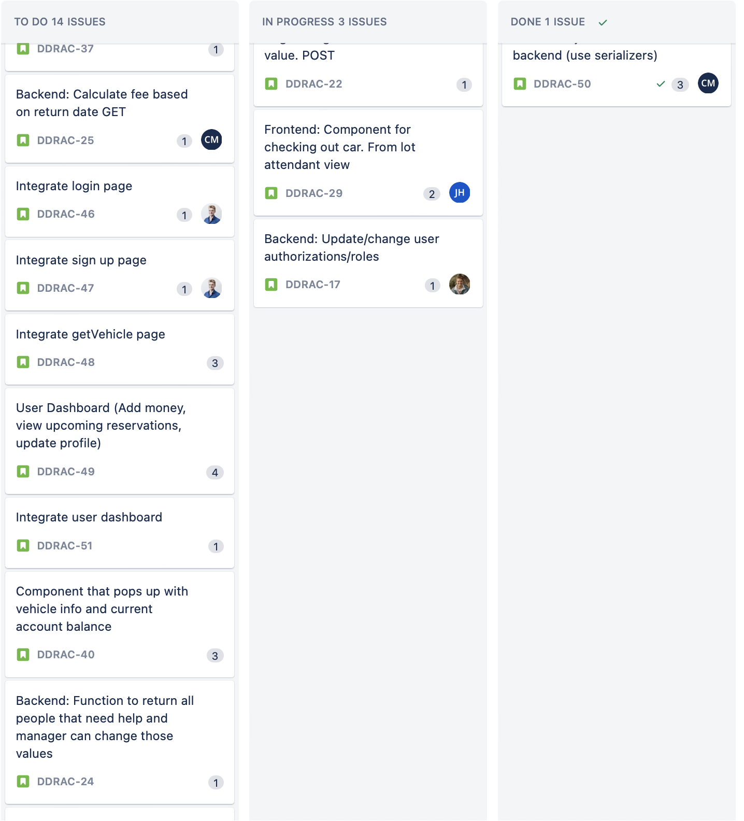

# Screenshot of you project board

